Name: Bestha Akshaya Course code: DSA0607
Regno:192424336 Course name: Data handling& visualization
Slot D
LAB EXPERIMENTS
6.
Code:
Date <- c("2023-01-01",
"2023-01-02",
"2023-01-03",
"2023-01-04",
"2023-01-05")
Page_Views <- c(1500,1600,1400,1650,1800)
Click_Through_Rate <- c(2.3,2.7,2.0,2.4,2.6)
website <- data.frame(Date,
Page_Views,
Click_Through_Rate)
print(website)
plot(website$Page_Views,
type="o",
col="blue",
xaxt="n",
xlab="Date",
ylab="Page Views",
main="Daily Page Views Trend")
axis(1,
at=1:5,
labels=website$Date)
legend("topleft",
legend="Page Views",
col="blue",
lty=1,
pch=16)
barplot(website$Click_Through_Rate,
names.arg=website$Date,
main="Click Through Rate by Date",
xlab="Date",
ylab="CTR (%)",
col="orange",
border="black")
Likes <- c(120,150,130,160,180)
Shares <- c(60,70,65,75,80)
Comments <- c(30,35,32,40,45)
interaction <- rbind(Likes,
Shares,
Comments)
x <- 1:5
colors <- c("skyblue","orange","lightgreen")
plot(x,
Likes,
type="n",
ylim=c(0,max(colSums(interaction))),
xlab="Date",
ylab="Interactions",
xaxt="n",
main="User Interactions")
axis(1,
at=1:5,
labels=Date)
polygon(c(x,rev(x)),
c(rep(0,5),rev(Likes)),
col=colors[1],
border=NA)
polygon(c(x,rev(x)),
c(Likes,rev(Likes+Shares)),
col=colors[2],
border=NA)
polygon(c(x,rev(x)),
c(Likes+Shares,
rev(Likes+Shares+Comments)),
col=colors[3],
border=NA)
legend("topleft",
legend=c("Likes","Shares","Comments"),
fill=colors)
OUTPUT: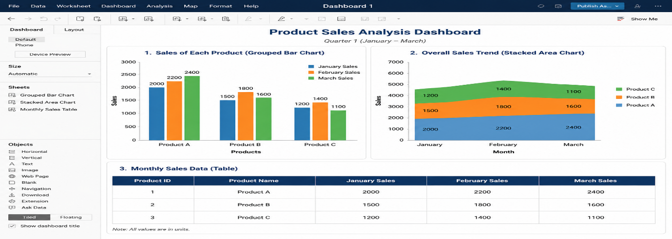
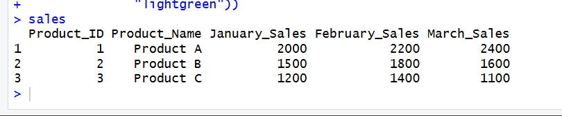
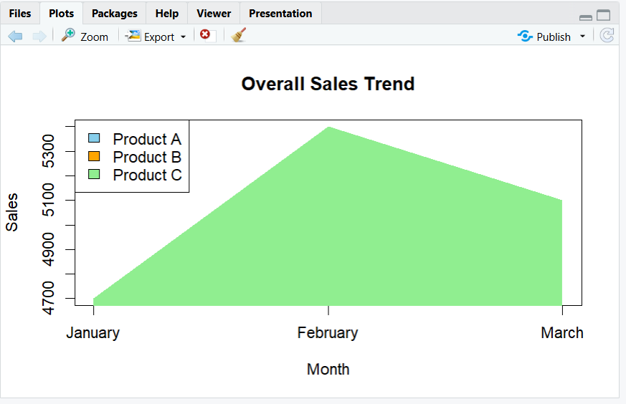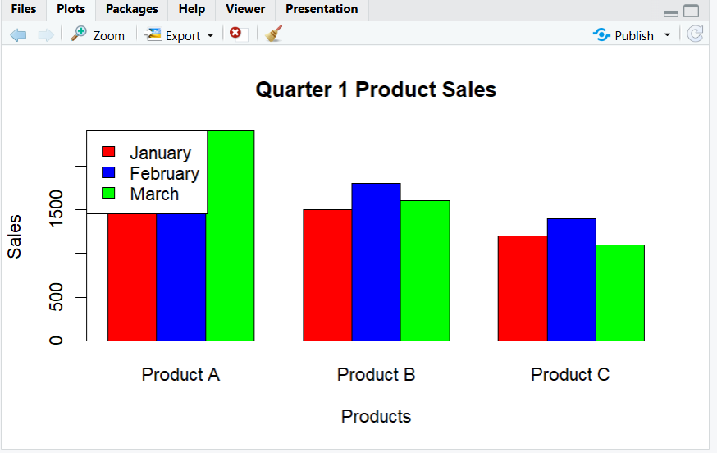
7.
Code:
# Customer Demographics Dataset
Customer_ID <- c(1,2,3)
Age <- c(28,35,42)
Gender <- c("Female","Male","Female")
Income <- c(50000,60000,75000)
customer <- data.frame(Customer_ID,
Age,
Gender,
Income)
print(customer)
barplot(customer$Age,
names.arg=customer$Customer_ID,
main="Customer Age Distribution",
xlab="Customer ID",
ylab="Age",
col="skyblue",
border="black")
gender_count <- table(customer$Gender)
pie(gender_count,
main="Customer Gender Distribution",
labels=names(gender_count),
col=c("pink","lightblue"))
View(customer)
OUTPUT:
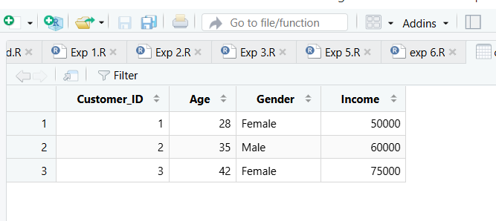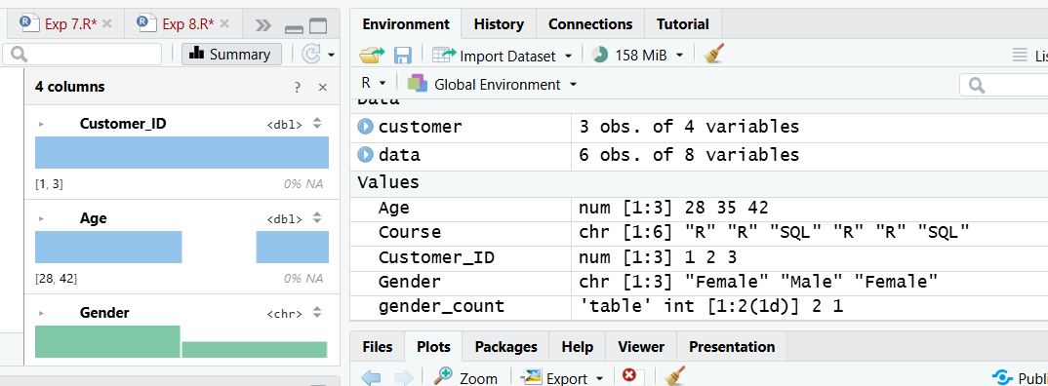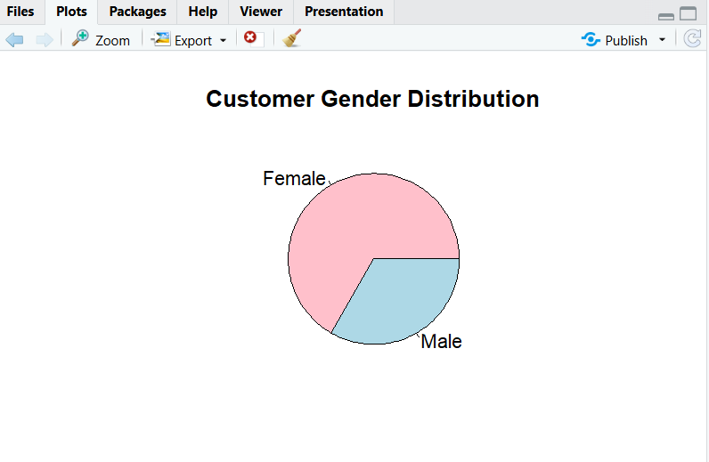

8.
Code:
# Create Data set
Student_ID <- c("L01","L02","L03","L04","L05","L06")
Gender <- c("Male","Female","Male","Female","Male","Female")
Age <- c(20,22,19,21,23,20)
Course <- c("R","R","SQL","R","R","SQL")
Study_Time <- c(3.5,4.2,2.0,5.0,2.5,4.0)
Videos_Watched <- c(12,15,8,18,9,14)
Quiz_Score <- c(78,85,65,92,70,88)
Login_Date <- c("2025-01-05","2025-01-05","2025-02-08",
"2025-02-08","2025-03-12","2025-03-12")

data <- data.frame(Student_ID,
Gender,
Age,
Course,
Study_Time,
Videos_Watched,
Quiz_Score,
Login_Date)

print(data)
hist(data$Quiz_Score,
main="Distribution of Quiz Scores",
xlab="Quiz Score",
ylab="Frequency",
col="skyblue",
border="black")
plot(avg_score$Quiz_Score,
type="o",
xaxt="n",
col="blue",
xlab="Month",
ylab="Average Quiz Score",
main="Monthly Average Quiz Score")
axis(1,
at=1:nrow(avg_score),
labels=avg_score$Month)
moving_avg <- filter(avg_score$Quiz_Score,
rep(1/2,2),
sides=1)
lines(moving_avg,
col="red",
lwd=2)
legend("topleft",
legend=c("Average Score","Moving Average"),
col=c("blue","red"),
lty=1)
OUTPUT:
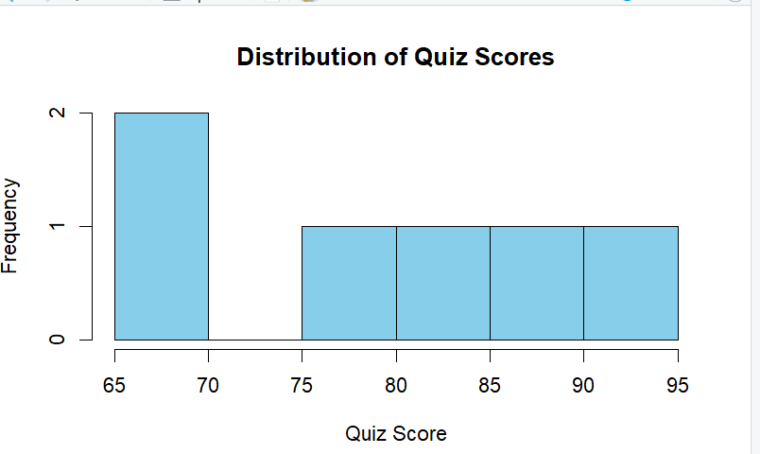
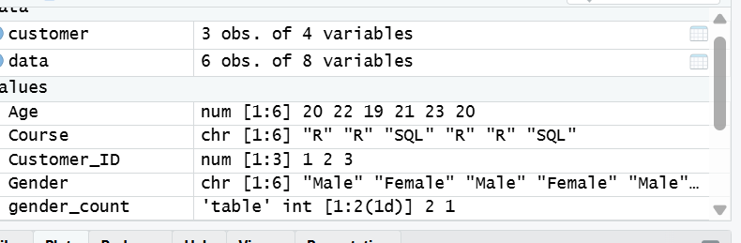
9.
Code:
# Survey Responses Dataset
Survey_ID <- c(1,2,3)
Question1 <- c("A","B","C")
Question2 <- c("B","A","A")
Question3 <- c("C","D","B")
survey <- data.frame(
Survey_ID,
Question1,
Question2,
Question3
)
print(survey)
q1 <- table(survey$Question1)
barplot(q1,
main="Distribution of Question 1 Responses",
xlab="Responses",
ylab="Frequency",
col=c("red","blue","green"),
border="black")
response_table <- rbind(
table(survey$Question1),
table(survey$Question2),
table(survey$Question3)
)
barplot(response_table,
beside=FALSE,
col=rainbow(nrow(response_table)),
main="Overall Distribution of Survey Responses",
xlab="Response Options",
ylab="Frequency",
legend.text=c("Question 1","Question 2","Question 3"))
View(survey)
OUTPUT:
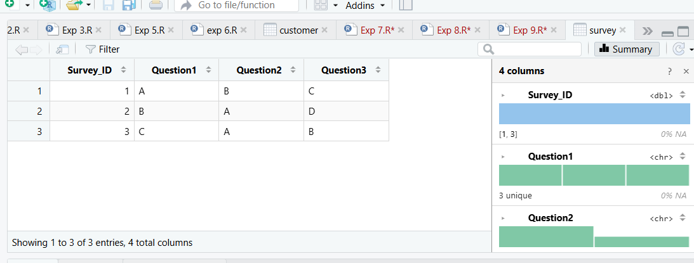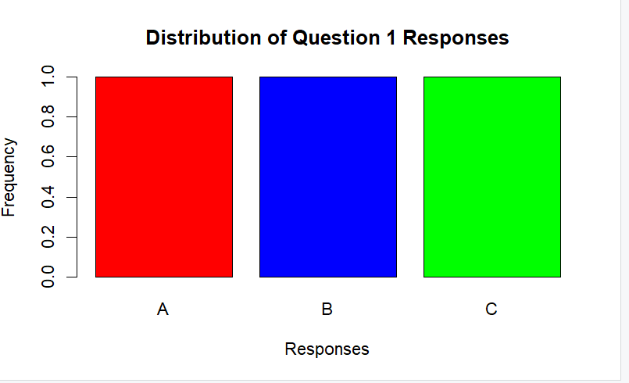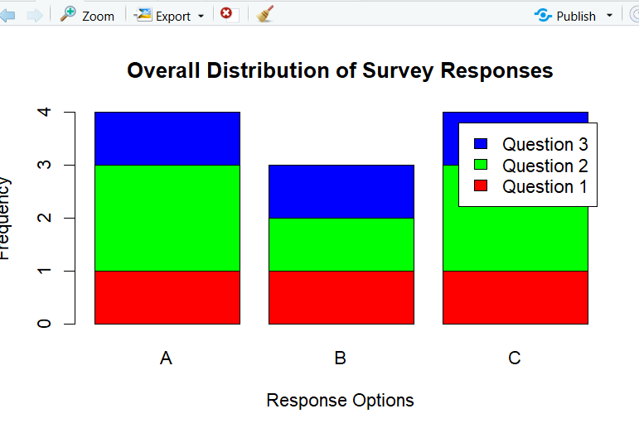

10.
Code:
# Product Category Dataset
Category <- c("Electronics",
"Clothing",
"Appliances")
Sales <- c(50000,
35000,
40000)
product <- data.frame(Category,
Sales)

print(product)
barplot(rev(product$Sales),
horiz=TRUE,
names.arg=rev(product$Category),
col=c("skyblue","orange","lightgreen"),
main="Sales Conversion Funnel",
xlab="Sales ($)",
border="black")
View(product)
pie(product$Sales,
labels=product$Category,
main="Sales Distribution by Product Category",
col=c("skyblue","orange","lightgreen"))

OUTPUT:
